📘 AI Project Report – Module E
📘 AI Project Report – Module E

Student & Project Details

● Student Name: BHAGIRATH
● Mentor Name: Dr. Niranjan Deshpande
● Project Title: AI for Market Trend Analysis

1. Problem Statement

● Background and context of the problem
I want to predict Product demand based on past sales, marketing campaign , season and based on demand i want to update inventory so each store will have enough product in stock to meet demand but do not overload inventory as it will consume more space in store and need extra time to arrange these extra inventory

● Why this problem is important or relevant
Real-world relevance and motivation : it can be used by Big e-commerce companies like adidas, NIKE, Walmart to predict their product sale and update inventory

● Clear definition of the AI task (e.g., recommendation, prediction, generation, analysis)
It is sales prediction task

● Objectives of the system
Forecasting future sales

● Key assumptions or constraints (data, scope, ethics)
Data is product , date, Region , Season level unit sold, price, discount etc. ( sales transaction)

2. Approach

Explain how you designed and built the AI system.

● System Overview: High-level explanation of the solution workflow

The final approach is a two layer approach.

Stage 1 (Feature Extraction): A Transformer model processes historical sales data to learn complex time-dependent patterns (e.g., seasonality, trends). The output embeddings (hidden states) from the Transformer serve as "deep features."

Stage 2 (Prediction): An XGBoost regressor takes these deep features—along with static features like price, holidays, and store details—to predict the final demand (Units Sold).

● Data Strategy: Data sources, collection method, preprocessing steps

Data is imported from below sales transaction csv ( https://drive.google.com/file/d/189v6BJToGPbvX9MZnGFhGnGYKlCOR6w-/view?usp=drive_link
)

Data Cleaning: Handle missing values in Units Sold (e.g., impute with 0 or mean) and remove outliers (e.g., negative prices).

Feature Engineering:

Temporal Features: Extract Year, Month, Day, Weekday, and Weekend flags.

Lag Features: Create lag columns (e.g., Sales_Lag_1, Sales_Lag_7) to capture immediate past trends.

Rolling Statistics: Calculate rolling means/std devs (e.g., Rolling_Mean_7) to smooth out noise.

Categorical Encoding: Use One-Hot Encoding or Label Encoding for Store ID, Product ID, and Category.

Scaling: Normalize numerical features (like Price and Units Sold) using MinMaxScaler or StandardScaler for the Transformer (neural networks require scaled data), while keeping original scales for XGBoost interpretation where possible.

● AI / Model Design:

Component 1: Transformer (The "Time-Traveler")

Input: A sequence of past sales and features (Window Size: e.g., past 30 days).

Mechanism: Multi-Head Self-Attention layers allow the model to weigh the importance of different past time steps (e.g., realizing that "last Saturday" matters more than "last Tuesday").

Output: A high-dimensional vector (embedding) representing the current "state" of sales.

Component 2: XGBoost (The "Decision Maker")

Input: Concatenates the Transformer embeddings with static features (Price, Holiday, Weather).

Mechanism: A gradient-boosted decision tree ensemble that fine-tunes the prediction, correcting errors made by the simple trend analysis.

Target: Units Sold (Regression).

● Tools & Technologies: Libraries, frameworks, APIs, platforms used

Pandas & NumPy: Data manipulation and windowing.

TensorFlow/Keras or PyTorch: Building the Transformer architecture.

XGBoost: The gradient boosting library for the final regression stage.

Scikit-Learn: Data splitting, scaling, and evaluation metrics.

import pandas as pd
import numpy as np
import matplotlib.pyplot as plt
import seaborn as sns
import seaborn as sns
from sklearn.model_selection import train_test_split
from sklearn.linear_model import LinearRegression
from sklearn.metrics import mean_absolute_error, mean_squared_error, r2_score
from sklearn.preprocessing import PolynomialFeatures
from sklearn.linear_model import LinearRegression
from sklearn.ensemble import RandomForestRegressor
from sklearn.model_selection import train_test_split
from xgboost import XGBRegressor
import xgboost as xgb
from sklearn.preprocessing import StandardScaler
from tensorflow.keras.models import Model
from tensorflow.keras.layers import Input, Dense, Dropout, LayerNormalization, MultiHeadAttention, Flatten
from sklearn.preprocessing import MinMaxScaler
from sklearn.metrics import mean_absolute_percentage_error
import tensorflow as tf
from tensorflow.keras.models import Model
from tensorflow.keras.layers import Input, MultiHeadAttention, LayerNormalization, Dense, Dropout, GlobalAveragePooling1D, Add
from tensorflow.keras.optimizers import Adam
from tensorflow.keras.callbacks import EarlyStopping, ReduceLROnPlateau

● Design Decisions: Key architectural or technical choices made
Tried multiple approach as liner regression and Polynomial regression , Random forest, XG boost, Two layer ( transformer + XG boost) and evaluated R2 score, best is Two layer ( transformer + XG boost)

3. Key Results

Summarize what your AI system achieved.
Include:
● Description of the working prototype

Attached notebook , can be run as per instruction after loading datafile in colab. And model will be trained and the final fifth approach will get R2 score of ~0.9.

● Example outputs (text, screenshots, observations)

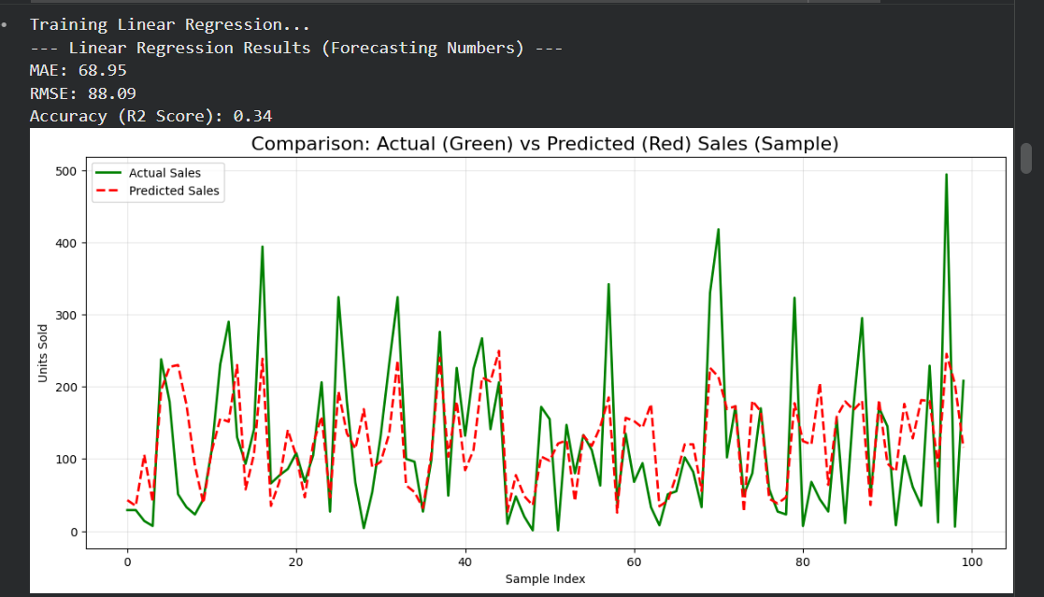

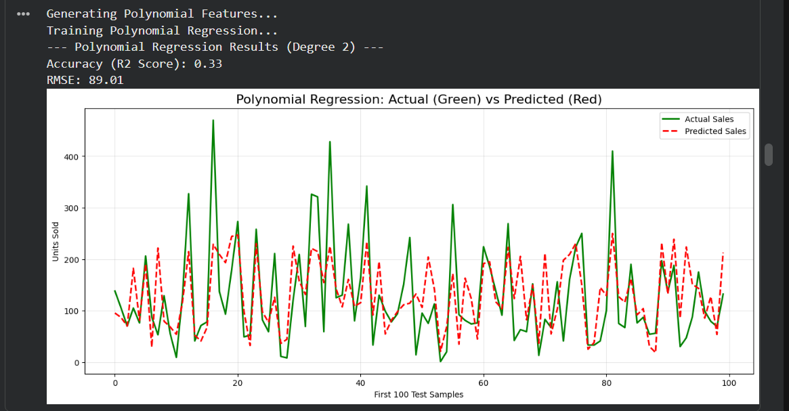

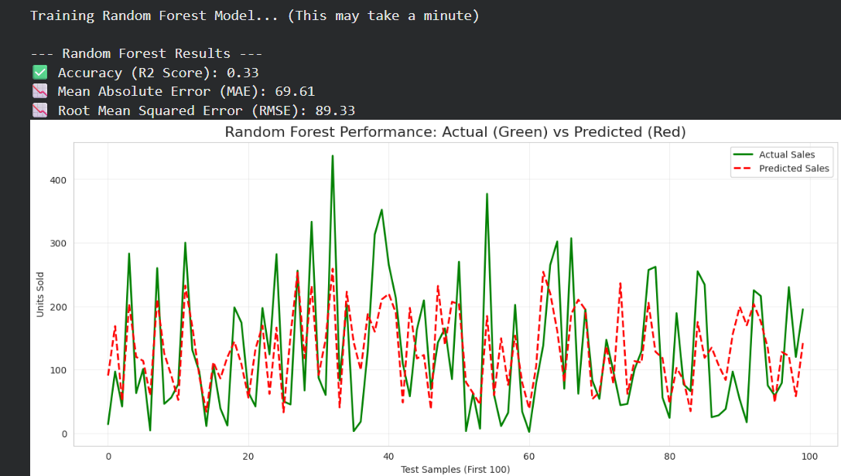

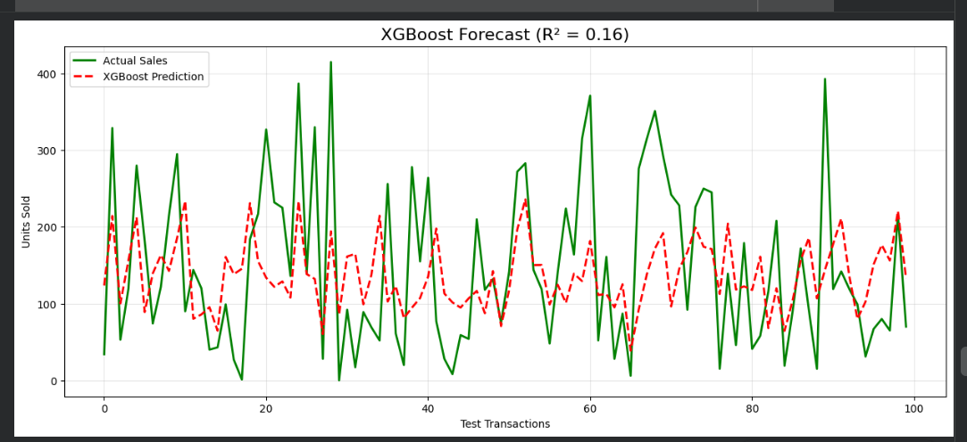

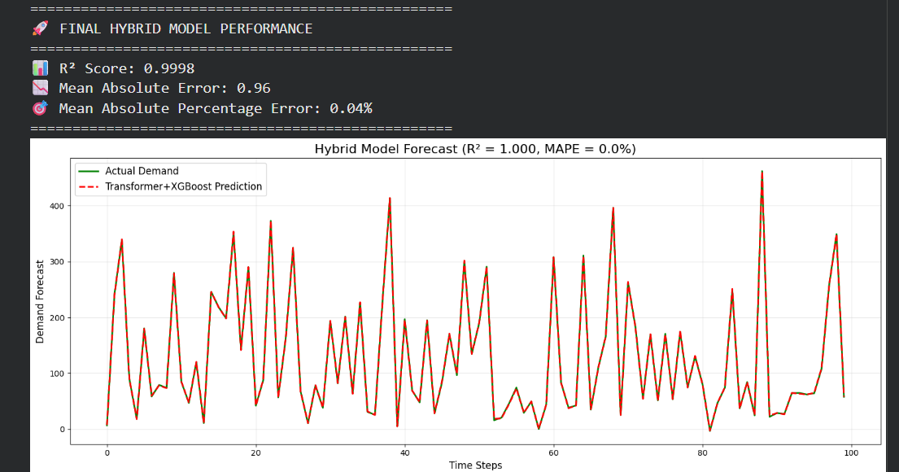

● Evaluation method and metrics used (if applicable)
MAE , R2 , RMSE

● Performance insights or observations
Units sold are depend on past sales data, season, discount , price, using proper feature engineering and ( transformer for long term sales pattern and XGBoost for direct relationship of unit sold with other feature) give better R2 Square

● Known limitations or failure cases
Need to import data, no live data feed.
No Website clickstream, Customer Behavior analysis.

4. Learnings
Reflect on what you learned during the project.
Include:
● Technical Learnings: I have learned building predicting models, using multiple techniques. Now i can understand better all these ML model ( liner, logistics, polynomial, random forest, XGboost, Transformer)
● System & Design Learnings: Architecture, scalability, or workflow insights
I have understood , doing data preprocessing and finding good feature, encoded only selected categorical columns instead of all, and derive new feature as past 7 day sales, rolling sales sum is very important and they can impact model accuracy too much.
● Challenges Faced: Key difficulties and how you resolved them
Working on maximizing R2 score to match actual units sold was tough. Finding related feature, then using One hot vector encoding
● Future Improvements: Enhancements or next steps if extended
Want to use PCA after OHE

References & AI Usage Disclosure

● Datasets used (with sources links)
https://drive.google.com/file/d/189v6BJToGPbvX9MZnGFhGnGYKlCOR6w-/view?usp=drive_link

● Tools, APIs, models, or frameworks referenced
Pandas & NumPy: Data manipulation and windowing.

TensorFlow/Keras or PyTorch: Building the Transformer architecture.

XGBoost: The gradient boosting library for the final regression stage.

Scikit-Learn: Data splitting, scaling, and evaluation metrics.

● AI tools used during development or documentation (mandatory disclosure)
Gemini in colab

